|  |  |  |  |  |  |  |  |  |  |  |  |  |  |  |
| --- | --- | --- | --- | --- | --- | --- | --- | --- | --- | --- | --- | --- | --- | --- |
| **PROJECT REPORT**  **Title: HealthAI: Intelligent Healthcare Assistant Using IBM Granite**       1. **INTRODUCTION**     1. ***Project Overview***   **HealthAI** is an intelligent healthcare assistant powered by IBM Watson Machine Learning and Generative AI. It aims to enhance accessibility to reliable medical insights by offering users accurate, personalized, and data-driven guidance. Users can interact with HealthAI through a responsive single-page web application, gaining support for diagnosis, treatment, and daily health tracking.   * 1. ***Purpose***   The purpose of HealthAI is to serve as a virtual healthcare companion, helping users understand symptoms, receive predictive diagnoses, and access evidence-based treatment suggestions through a user-friendly interface.       1. **IDEATION PHASE**     1. ***Problem Statement***   In today’s digital world, people often turn to the internet for health-related queries, but struggle with information overload, inconsistent sources, and lack of personalization. **HealthAI** addresses this gap by providing trusted, AI-powered medical insights tailored to the user’s inputs and conditions.   * 1. ***Empathy Map Canvas***   The empathy map helps understand the target users' mindset and expectations when interacting with a virtual health assistant like HealthAI.   |  |  | | --- | --- | | Category | Description | | Says | "I want quick answers to my health questions.""Is this symptom serious?" | | Thinks | "Can I trust this information?""Will this help me avoid a hospital visit?" | | Does | Searches symptoms online. Asks friends or family for medical advice | | Feels | Anxious about symptoms. Uncertain about next steps | | Pains | Conflicting online information. Lack of access to immediate healthcare | | Gains | Reliable AI suggestions. Quick advice at home. Health tracking insights |  * 1. ***Brainstorming***   The team explored various ideas such as mental health bots, COVID symptom trackers, and AI nutritionists before settling on an all-in-one intelligent assistant with chat, prediction, and analytics powered by IBM Watson. |

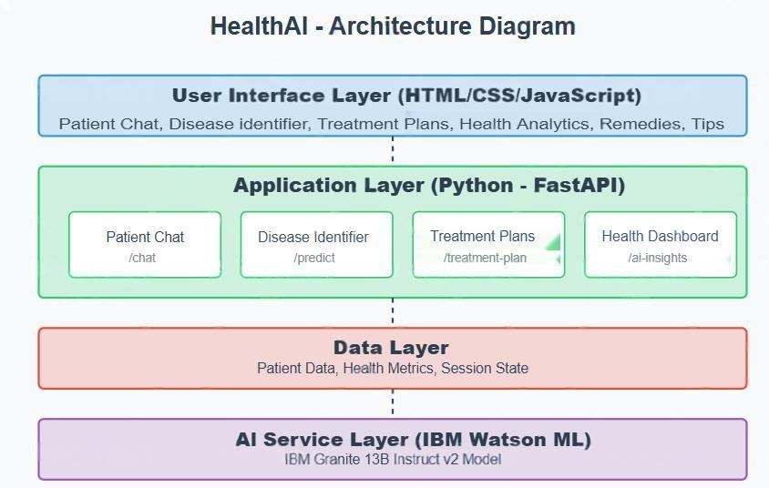

**3.**

**REQUIREMENT ANALYSIS**

**3.1**

**Customer Journ**

**ey Map**

The customer journey in the HealthAI application follows a streamlined, user

-

friendly process:

1.

**Start Application**

–

The user opens the HealthAI web app (built using HTML, CSS, JavaScript).

2.

**Input Health Query**

–

The user types a symptom

-

related question or fills out a

symptom form.

3.

**Receive Diagnosis**

–

The AI model (IBM Granite via FastAPI) responds with likely

conditions and guidance.

4.

**Review Treatment Plan**

–

The app displays a structured, AI

-

generated treatment

recommendation.

5.

**View Health Analytics**

–

Users visualize vital signs like heart rate, blood pressure, and

glucose with Chart.js insights.

6.

**End/Next Action**

–

The user can reset the session, consult a doc

tor, or continue exploring

HealthAI features.

***3.2***

***Session Requirements***

●

Real

-

time symptom input via chat

●

Prediction based on user profile

●

Personalized treatment plans

●

Visualization of health

metrics

***3.3***

***Data Flow Diagram***

***3.4***

***Technology Stack***

●

**Frontend:**

HTML, CSS, JavaScript (Single Page Application)

●

**Backend:**

Python (FastAPI)

●

**AI Service:**

IBM Watson ML (Granite 13B Instruct v2)

●

**Visualization:**

Chart.js

●

**Environment Management:**

virtualenv + .env (python

-

dotenv)

**4.**

**PROJECT DESIGN**

***4.1***

***Problem***

***-***

***Solution Fit***

People need quick, understandable, and trustworthy health information. HealthAI fulfills this by

using medical LLMs for better accuracy.

***4.2***

***Proposed Solution***

A layered web application consisting of a dynamic UI (HTML/JS), application logic (FastAPI),

and an AI backend (IBM Granite). It guides users from symptom input to personalized treatment

suggestions and visual analytics.

***4.3***

***Solution Architecture***

●

**UI Layer:**

Cha

t interface, forms, and analytics dashboard (SPA using HTML/CSS/JS)

●

**Application Logic:**

main.py handles routing, input processing and API calls.

●

**Helper Logic:**

Utility functions for prompt formatting and session management

●

**AI Layer:**

IBM Granite 13B Instruct v2 connected via secure FastAPI endpoints using .env

credentials

**5.**

**PROJECT PLANNING & SCHEDULING**

***5.1***

***Project Planning***

**Week**

**Duration**

**Dates**

**Activities**

Week 1

June 12

–

June 19

Idea finalization, architecture planning,

frontend UI (HTML/JS)

Week 2

June 20

–

June 26

FastAPI backend + AI integration, testing, and

documentation

This two

-

week schedule allowed the team to focus on clear milestones and complete the HealthAI

project within the planned timeline.

**6.**

**FUNCTIONAL AND PERFORMANCE TESTING**

***6.1***

***Performance Testing***

●

Unit Testing: Model loading, session data handling

●

Integration Testing: End

-

to

-

end chat → prediction → plan → visualization

●

Manual Testing: Validated each module with sample health queries

●

Error Handling: Graceful handling of missing/invalid inputs, API key issues

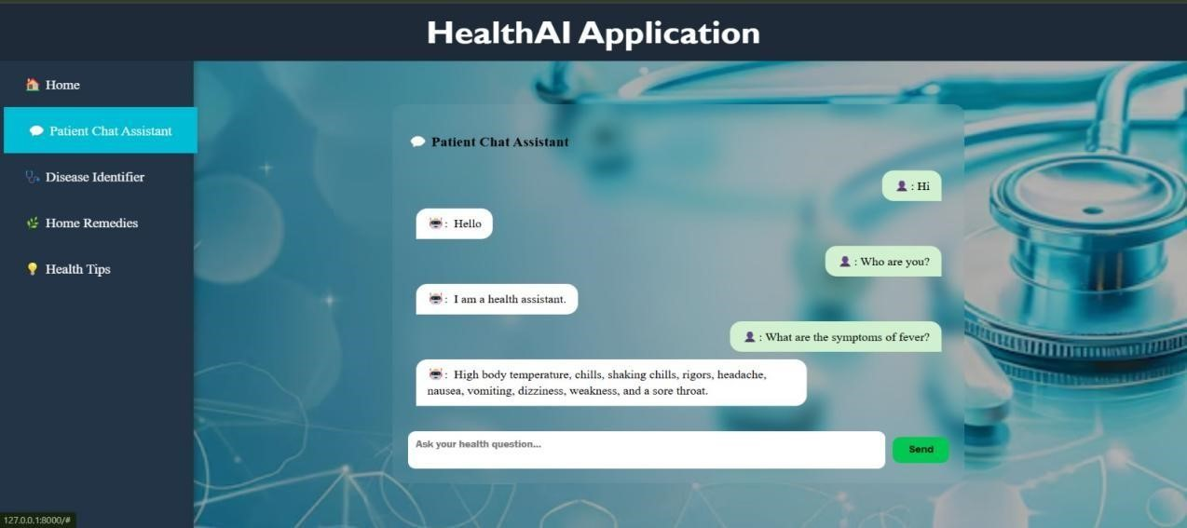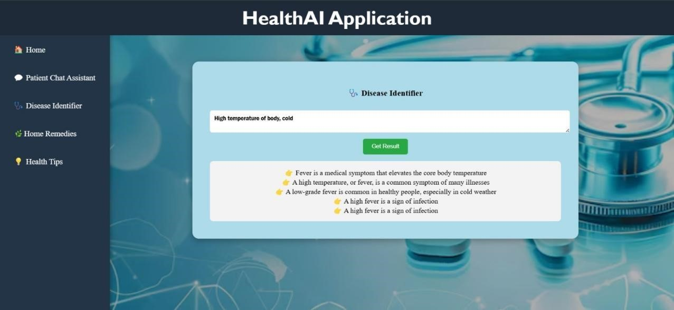

**7.**

**RESULTS**

***7.1***

***Output Screenshots***

⮚

Screenshot of chat feature

⮚

Screenshot of prediction result

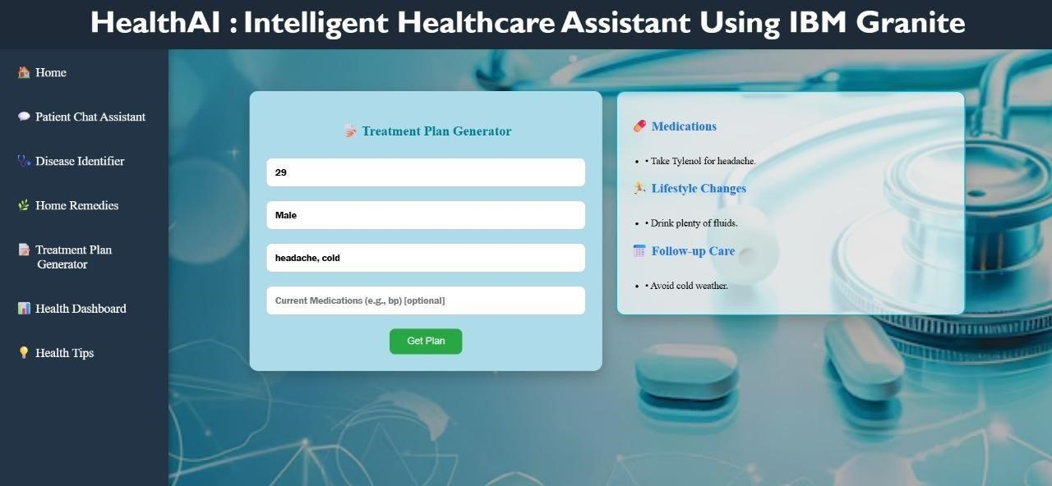

⮚

Screenshot of treatment plan generator

⮚

Screenshot of treatment plan generator

⮚

Screenshot of health tips generator

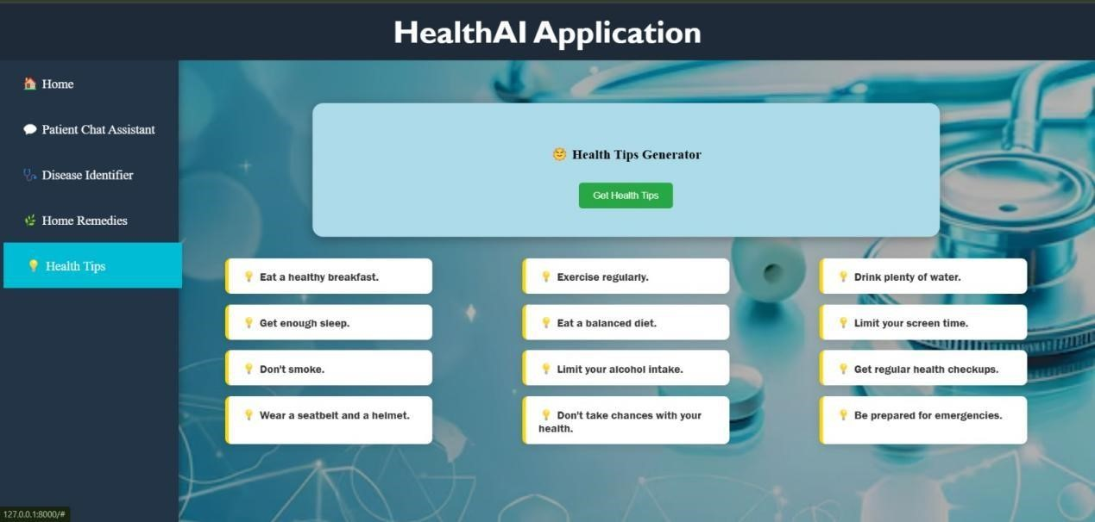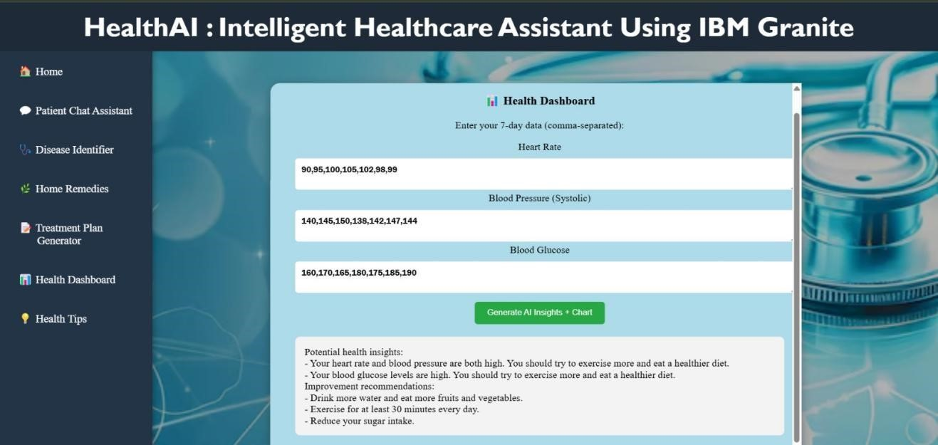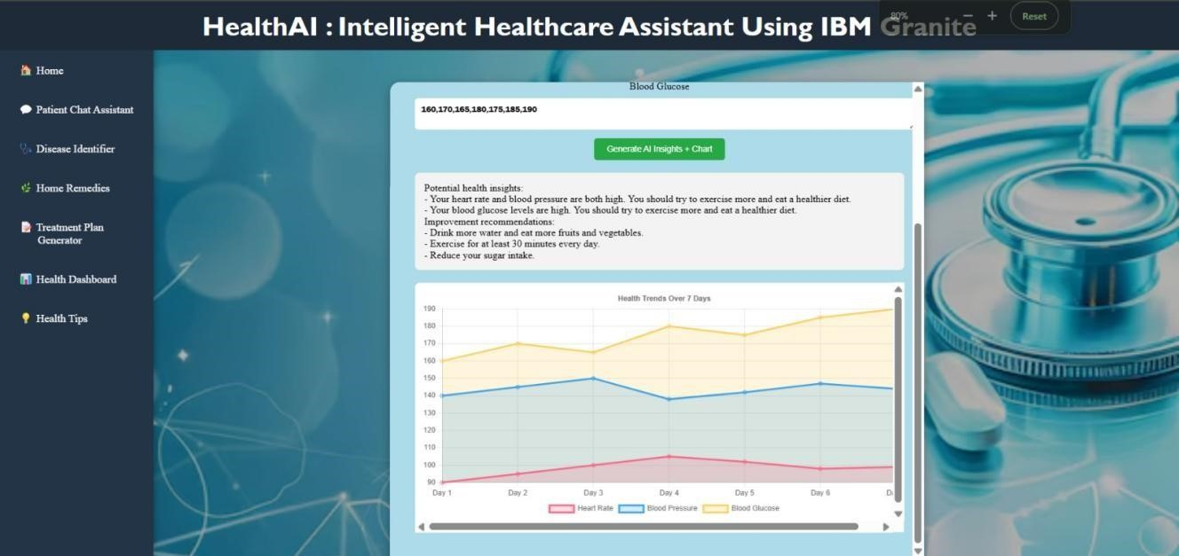

⮚

Screenshot of health analytics chart

# ADVANTAGES & DISADVANTAGES

**Advantages:** - Easy to use - AI-powered recommendations - Visualization of health data

**Disadvantages:** - No real-time data integration - No authentication or user profiles - General- purpose AI model

# CONCLUSION

**HealthAI** successfully demonstrates the application of AI in healthcare by combining a simple and intuitive user interface with powerful backend intelligence using IBM WatsonX Granite. Developed as a modular web-based application, it offers chat-based health guidance, symptom- based predictions, and treatment suggestions. While currently a prototype, it provides a strong foundation for real-world deployment with future enhancements such as real-time health data integration, secure user authentication, and multilingual support.

# FUTURE SCOPE

* Add secure user login and profile management
* Use real anonymized patient databases for prediction accuracy
* Integrate with wearable devices like smartwatches for live health monitoring
* Fine-tune IBM Granite model on domain-specific medical data
* Add features like emergency alerts, appointment booking, and multilingual support

# APPENDIX

* <https://github.com/reddysowmya123/HealthAI-Intelligent-Healthcare-Assistant-Using-IBM-Granite>
* **Source Code Files:** main.py,index.html,styles.css,app.js,.env

|  |
| --- |
|  |